7.11: Take 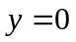 at point A. Let point 1 be A and point 2 be B.
